System 03: what the optimisation tells us
Preference-based design optimisation of The Ocean Cleanup’s System 03. Results and interpretation.
In short
- Scale up, in every scenario. With min-max aggregation the best design deploys two systems (technical and social cycle) or three (environmental priority), always at the widest vessel spacing allowed. One system removes at most about 1,300 t of plastic per year within the physical limits, which leaves The Ocean Cleanup half satisfied at best.
- Who is heard decides how the fleet is towed. The optimum moves from 0.61 m/s with a 10 mm mesh (equal weights) to 0.29 m/s with a 20 mm mesh (environmental priority). Bycatch per tonne of plastic drops from 66 to 21 animals.
- Today’s single system is the best compromise on average. In the technical and the social cycle its average satisfaction is higher than that of the min-max optimum, and a-fine and Tetra choose one system in all three cycles. Min-max rejects it because The Ocean Cleanup stays at 44 out of 100.
- Fleet size is a funding question. If the donors’ budget limits double, the optimum moves from two to four systems.

1. The model in brief
The model describes a fleet of System 03 units with five design variables and scores every design for five stakeholders. Each stakeholder has one objective, a preference curve that turns the objective value into a score from 0 to 100, and a weight. A genetic algorithm searches for the design with the best group preference. Formulas, constants and sources are in OceanCleanup_System03.ipynb and Constants_and_Sources.ipynb.
Design variable | Bounds | Today | A higher value means
Skirt depth | 3 – 6 m | 4 m | less plastic lost under the skirt; more drag, and fish escape less easily
Vessel spacing | 520 – 1,800 m | 1,460 m | more plastic met; more drag and fuel, more bycatch
Number of systems | 1 – 20 | 1 | plastic, cost, bycatch and closed sea area all scale with the fleet
Towing speed | 0.26 – 1.29 m/s | 0.75 m/s | more plastic met, but more escapes under the skirt (best near 1.0 m/s); more fuel, and animals avoid the barrier less
Mesh size | 10 – 20 mm | 16 mm | fewer small fish retained; slightly less plastic retained

Stakeholder | Objective | Preference curve: ideal / halfway / unacceptable | Weight T · S · E
Investors / donors | Annual cost (low) | 7.5 / 30 / 60 M€ per year | 0.20 · 0.225 · 0.15
The Ocean Cleanup | Plastic removal (high) | 7,200 / 1,100 / 0 t per year | 0.20 · 0.30 · 0.20
Commercial fishers | Sea area closed to fishing (low) | 0 / 25 / 40 km² | 0.20 · 0.175 · 0.15
Conservation advocates | Bycatch (low) | T: 2,900 / 145,000 / 290,000 animals per year  S: 2,900 / 72,500 / 174,000  E: 2,900 / 50,000 / 100,000 | 0.20 · 0.175 · 0.35
Citizens | Net microplastic formation (low) | T: −216 / −33 / 0 t per year  S and E: −216 / −20 / 0 | 0.20 · 0.125 · 0.15

Three cycles. Technical (T): equal weights. Social (S): the influence-based weights of our MCDA; after seeing the technical design, the conservation advocates tighten their curve and the citizens are satisfied sooner. Environmental priority (E): a second possible outcome of the stakeholder game, the MCDA scenario in which the advocates weigh most and accept at most twice today’s bycatch.
Three physical constraints. The tension in a towing line may not exceed the bollard pull of the vessel (1,700 kN), the plastic collected in 7 days must fit in the retention zone (25 t), and the fuel for a 49-day campaign must fit in the tanks (2.4 million litres). Together they exclude about 7 % of the design space: the corner where the skirt is deep, the spacing wide and the speed high.

2. Results
 | Today | Technical cycle | Social cycle | Environmental priority
Design
Number of systems | 1 | 2 | 2 | 3
Skirt depth [m] | 4.0 | 3.0 | 4.7 | 4.3
Vessel spacing [m] | 1,460 | 1,770 | 1,795 | 1,795
Towing speed [m/s] | 0.75 | 0.61 | 0.66 | 0.29
Mesh size [mm] | 16 | 10 | 18 | 20
Objectives
Cost [M€ per year] | 13.4 | 25.0 | 27.0 | 35.8
Plastic removal [t per year] | 863 | 1,768 | 1,960 | 1,324
Sea area closed to fishing [km²] | 4.5 | 9.2 | 9.2 | 13.7
Bycatch [animals per year] | 50,600 | 115,800 | 95,200 | 27,400
Net microplastic formation [t per year] | −25 | −52 | −57 | −39
Efficiency
Cost per tonne of plastic [k€] | 15.6 | 14.1 | 13.8 | 27.0
Bycatch per tonne of plastic [animals] | 59 | 66 | 49 | 21

Table 1. Today’s design and the min-max optimum of each cycle. Each column is one run of the notebook. Repeated runs give the same number of systems and nearly the same scores; skirt depth, speed and mesh shift a little between runs, because the optimum is flat in these directions.
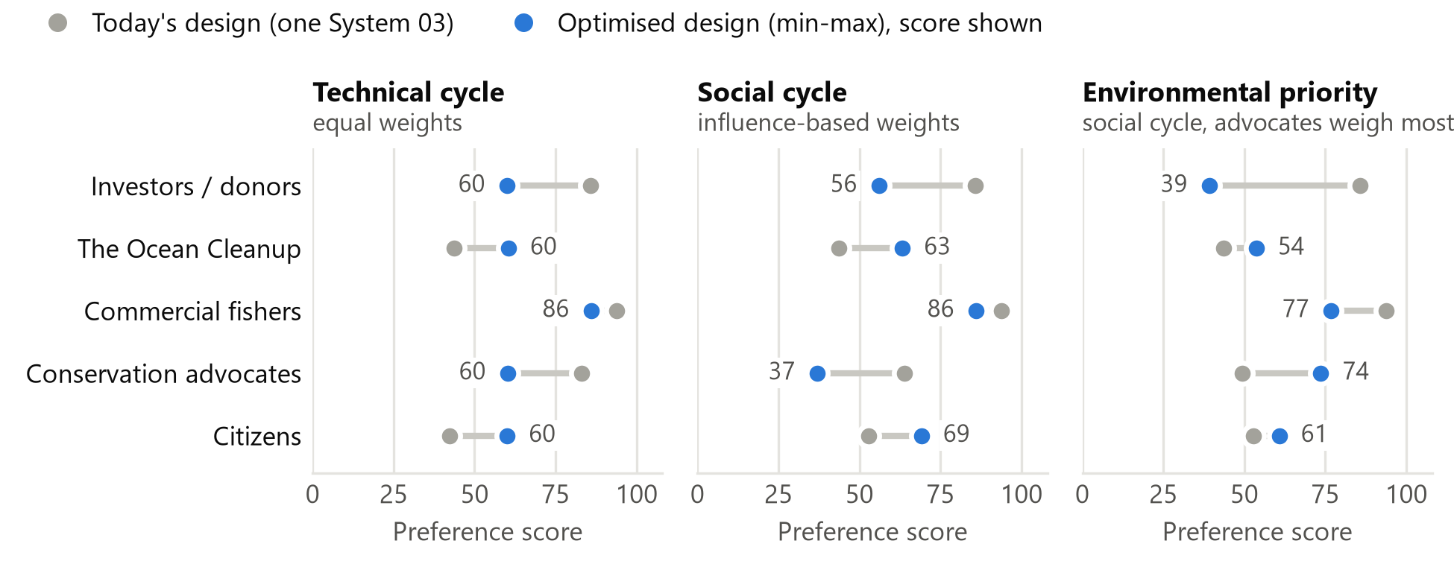
Figure 1. Who wins and who loses when today’s design is replaced by the min-max optimum. Both designs are scored with the preference curves of the cycle shown.
The plots of the notebook for the three cycles are Figures 2 to 4 in section 5.

3. Interpretation
Scale is the robust answer. Inside the physical limits one system removes at most about 1,300 t per year. That scores 53 out of 100 for The Ocean Cleanup and would catch about 180,000 animals. A second system is therefore the only way to lift The Ocean Cleanup from 44 to between 54 and 63. The donors stop the growth: their curve reaches zero at 60 M€ per year, about four and a half of today’s systems. In the technical and the social cycle, simply operating two of today’s systems already gives about 80 % of the improvement; retuning them gives the rest.
Wider is better, up to the bound. Every optimum sits at the upper spacing bound of about 1,800 m, against 1,460 m today. A wider mouth meets more plastic in proportion, while only about a tenth of the fuel use is towing work. This supports The Ocean Cleanup’s plan for wider systems. It also means that the bound, not a trade-off, sets this variable. Whether a flatter U still retains the plastic is the first thing to verify.
Influence changes how the fleet is operated, not how big it is. The social cycle keeps two systems. Its two changes pull in opposite directions. More weight for The Ocean Cleanup alone would raise the speed to 0.74 m/s and the bycatch by 44 %. The stricter curve of the advocates alone would halve the bycatch at 8 % less plastic. Together they give 11 % more plastic and 18 % less bycatch than the technical cycle. The lever is the mesh: going from 10 to 20 mm halves the small fish retained and costs less than 10 % of the plastic.
Environmental priority buys a slow fleet. Three systems at 0.29 m/s remove 53 % more plastic than today with 46 % less bycatch, 21 animals per tonne instead of 59. Animals avoid a slow barrier, and the third system buys back the plastic that each slow system misses. The price is 35.8 M€ per year, or 27 k€ per tonne instead of 15.6, and the investors fall to a score of 39.
Winners and losers (Figure 1). The investors lose whenever the fleet grows (86 today, then 60, 56 and 39). The Ocean Cleanup and the citizens win, and they move together: the microplastic avoided is 3 % of the plastic removed, so the two objectives depend on each other. Leaving the citizens’ objective out does not change the optimal design. The fishers never fall below 77, because a fleet closes only a few km²; in this model they are not a real party to the conflict. The advocates are the surprise. Between the technical and the social cycle their score falls from 60 to 37 although the bycatch falls by 18 %. The drop comes from their own stricter curve, and with influence-based weights min-max protects the influential stakeholders first.
The realised design is the compromise on average. Today’s single System 03 has a higher average satisfaction than the min-max optimum in the technical and the social cycle (70 and 67 against 65 and 62). A-fine, which rewards the average, and Tetra both choose one system in all three cycles. In the technical cycle Tetra’s design is today’s system with a wider spacing and a coarser mesh: 18 % more plastic at 3 % more cost and no more bycatch. Min-max asks a different question, namely that no stakeholder is left behind, and it rejects one system because The Ocean Cleanup stays at 44. The Ocean Cleanup’s own roadmap of 10 to 20 systems follows this second logic with a larger budget. In our model doubling the donors’ limits gives four systems.

4. How far the conclusions hold
- Constraints. No constraint is active at an optimum; the min-max designs use at most 75 % of any limit. The design is decided by the preferences and the bounds, not by the physical limits.
- Bounds. The spacing ends at its upper bound in every cycle, and the mesh at its lower bound (technical) or upper bound (the two social cycles). The upper bounds of mesh (20 mm) and skirt depth (6 m) are our assumptions. The skirt depth is hardly determined: 3.0 to 5.5 m gives almost the same score.
- Absolute tonnes are optimistic. The model retains 71 % of the plastic that today’s design meets, against 40 % measured for System 03 (Sainte-Rose et al., 2026), and assumes year-round operation. The comparison between designs is more reliable than the tonnes themselves.
- Preferences are our judgement. The curves and both outcomes of the stakeholder game were set by us, not by the stakeholders. The fleet size follows directly from the donors’ cost curve.
- Solver. Min-max is reproducible: repeated runs give the same fleet size and almost the same scores. A-fine ends every run with the convergence warning of the genetic algorithm, because its scores are relative within a generation. We therefore use its result only qualitatively; every a-fine run chose one system.

5. Optimisation plots
Figures 2 to 4 are the output of the notebook for each cycle: the optimum of each aggregation method on the five preference curves, together with today’s design (red square). Figure 3 is the run stored in the notebook; Figures 2 and 4 are runs of the same notebook with the weights and preference curves of the other two cycles selected.
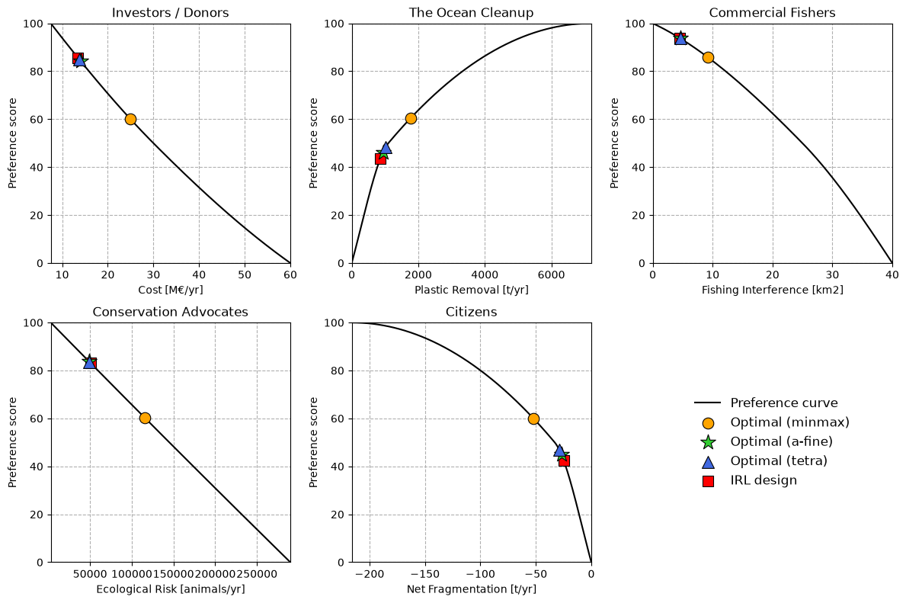
Figure 2. Technical cycle (equal weights). Min-max balances four stakeholders at a score of 60 with two systems; a-fine and Tetra stay close to today’s design.
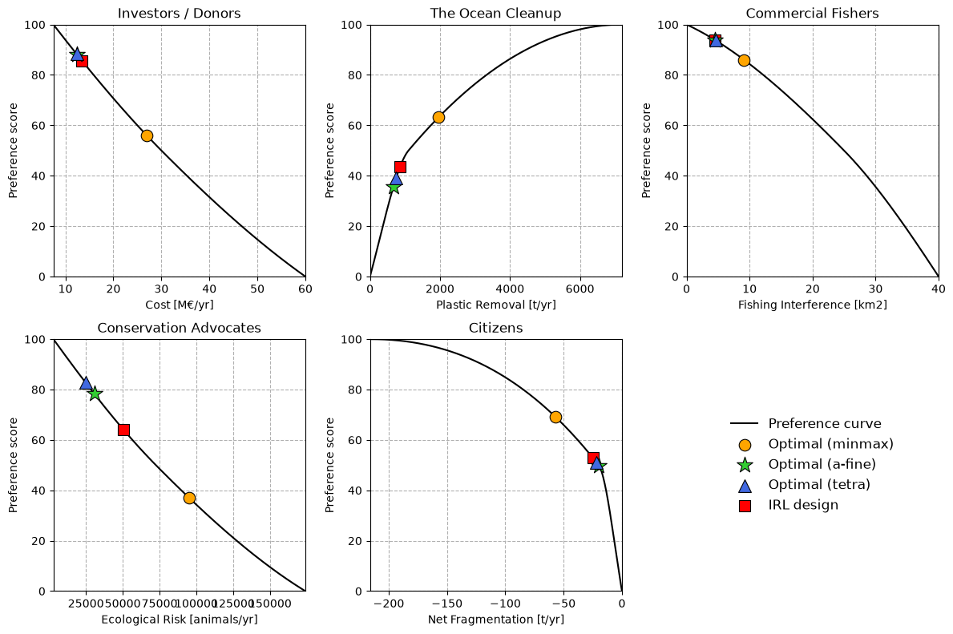
Figure 3. Social cycle (influence-based weights). Min-max keeps two systems but tows them faster with a coarser mesh; a-fine and Tetra stay with one system.
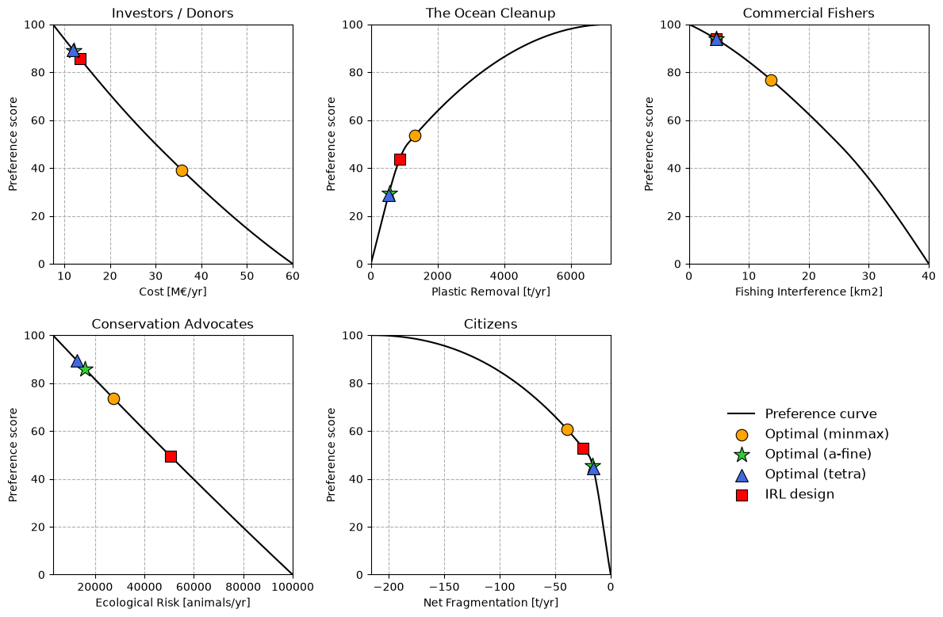
Figure 4. Social cycle with environmental priority. The curve of the conservation advocates is the strictest; min-max answers with three slow systems.
Sainte-Rose, B., Lebreton, L., Pham, Y., Tjallema, A., & Maes, C. (2026). Modelling the cleanup of the North Pacific Garbage Patch based on 3 years of operational experience. Scientific Reports, 16, 8050.

